Psalm 98 Common Worship
Chant: NN
Chant on a single line of music:
Or, on two lines of music for copying into narrow columns:
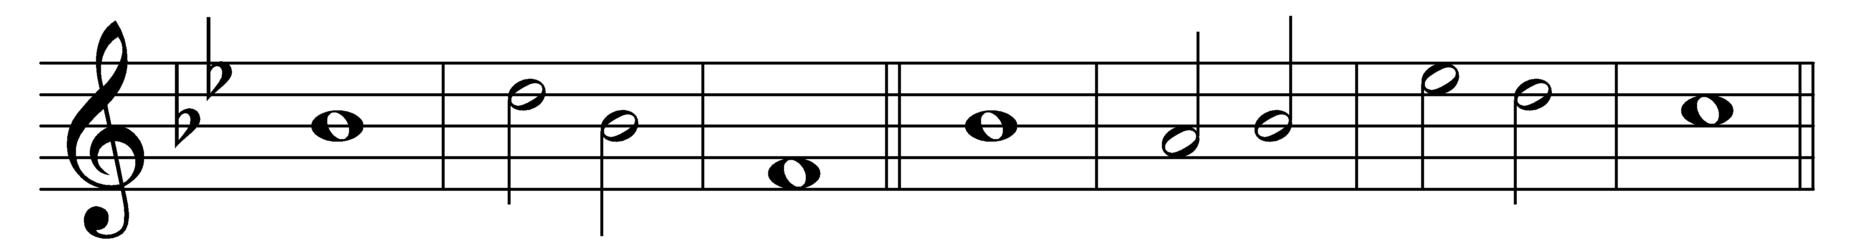
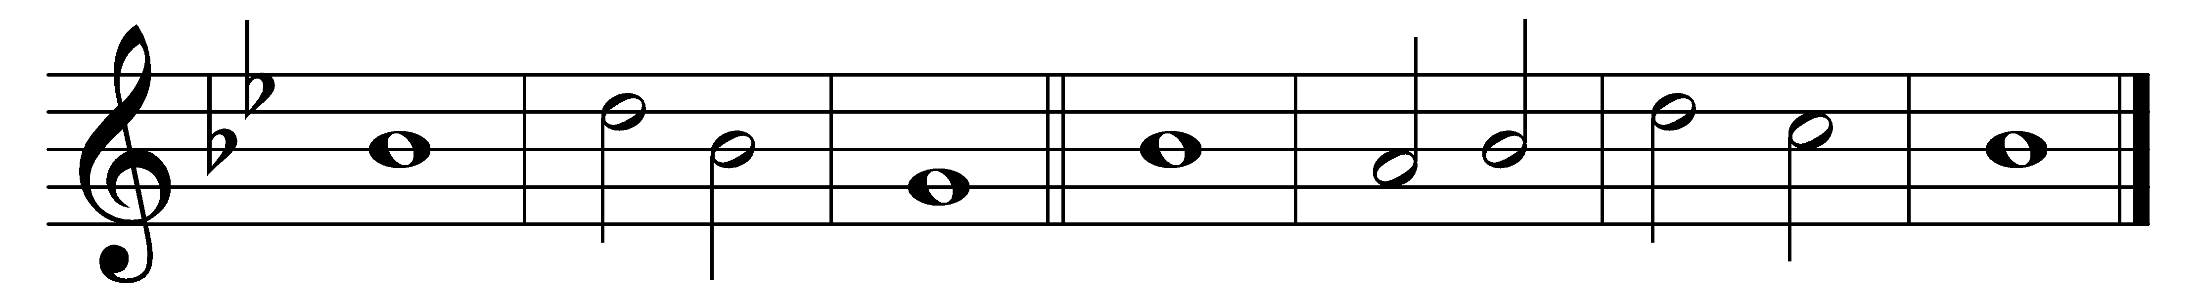
Sing to the | Lord a· new | song,
for he has | done | marvel-· lous | things.

2 His own right hand and his | holy | arm
have | won for | him the | victory.

3 The Lord has made | known his sal- | vation;
his deliverance has he openly | shown· in the | sight of· the | nations.

4 He has remembered his mercy and faithfulness towards the | house of | Israel,
and all the ends of the earth have seen the sal-| vation | of our | God.

5 Sound praises to the Lord, | all the | earth;
break into | singing | and make | music.

6 Make music to the | Lord· with the | lyre,
with the | lyre· and the | voice of | melody.

7 With trumpets and the | sound· of the | horn
sound praises be-| fore the | Lord, the | King.

8 Let the sea thunder and | all that | fills it,
the world and | all that | dwell up-| on it.

9 Let the rivers | clap their | hands
and let the hills ring out together before the Lord, for he | comes to | judge the | earth.

10 In righteousness shall he | judge the | world
– | and the | peo-|ples with | equity.

Words taken from Common Worship © The Archbishops’ Council 2000.

